**Flipkart mobile phone sales & reviews**



**San Jose State University, Department of Data Analytics**

**DATA 230: DATA VISUALIZATION**

**Professor: H. Andrew Bond**

**December 12, 2022**

**From**

**Hruthik Vinnakota**

**SJSU Student ID: 016047824**

**CONTENTS**

**Abstract**  4

**Project goals and motivation** 5

**Objectives** 6

**Data Description** 7

**Deliverables** 8

**Scope of work** 9

**Calculations field** 10

**Charts** 1 1

Data source project details 11

Number of mobile brands using a circle chart 12

Comparison between prices using a circle chart 13 13

lollypop graph including circle & bar charts 14

Bar chart of top 5 mobile brand’s rating status 15

Bar chart for mobile brand’s color rating 16

Comparison between internal memory with ram using a circle chart 17

Circle chart of a particular brand POCO 18

Bar chart of ram size and mobile count 19

Bar chart & circle chart of average rating count & average reviews count 20

Circle chat compares both the avg rating count & max rating count 21

The bar chart and grant chart price comparison 22

The Bar chart represents each star rating count of POCO product model 23

Dashboard 24

## First Dashboard – The original price vs the selling price of each mobile brand 24

Second Dashboard – The overview of POCO mobile brand 25

**Conclusion** 26

References 27

GitHub ID:

# **Abstract**

In this competitive world, there are multiple e-commerce websites. Among them, the Flipkart website is one of the leading e-commerce websites for all the global online retail services that allow customers to buy their products on the platform called ‘Flipkart.com’. Over the years the Flipkart platform has been expanding its total net revenue all over India because of its aggregate commitment to customer experience and satisfaction.

On the Flipkart website, most of the customers would like to buy the products according to the rating and reviews whereas the 5-star products, mobile devices, and other brands are the most trusted by the customers and are easy to be recommended and promoted more. Here in this project, I would like to analyze the various mobile phone sales of several brands traded by the Flipkart e-commerce website. My scrutiny and breakdown include a complete visualization of data that consists of a wide range of mobile brands, models, storage, stock availability, certain specifications including color, internal memory, ram, its highlights, selling and original prices, 1 - 5 stars rating, and reviews.

The overall conclusion of the result consists of various tableau sheets and dashboards which portray distinct visualization charts and graphs that simplify for end users to select the mobile phone of their choice from the Flipkart platform.

# **Project Goals and Motivation**

Numerous mobile brands and models are available on the e-commerce platform called “Flipkart” where customers have a lot of choices to choose what to buy online. So, this topic helps the customer’s decision straightforward. The goal of this project is to provide a fair analysis of various mobile brands to know their features and come up with useful conclusions.

The dataset contains various product models, highlights, price details, review details, and rating details of various smartphone brands in India from an e-commerce website known as ‘Flipkart’ for the search URL. To attain that we will create certain dashboards and stories by dividing them into different parts. We will create a dashboard for providing the current information on the Flipkart e-commerce platform regarding various smartphone brands in India with respective product models and their specifications. Additionally, will prepare dashboards by the customer’s choice of mobile and model to see its highlights.

# **Objectives**

* Packed bubble chart of the total number of mobile brands from Flipkart
* Total number of mobile brands along with their Average Original price & Average Selling price using scatter plot
* Top 10 Mobile phones and their sum of the total selling price
* Top 5 Mobile brands with an average rating out of 5
* The total sum of the average Rating of Brands according to color wise
* Comparing Ram with the Internal memory of mobile with its Average Rating and Average Rating count
* POCO Mobile Brands-Mobile Availability in Stock
* Mobile Brands along with RAM size and Mobile count
* Mobile Products along with Average Ratings and Reviews
* Mobile Products along with Maximum Rating and Average Ratings
* Mobile Data based on Brand, Model, Ram, and Internal Memory along with Average Original Price and Average Selling Price
* Mobile Data based on Brand, Model, Ram, and Internal Memory along with Average Original Price and Average Selling Price.

# **Data Description**

There are innumerable datasets available universally about various products from ‘Flipkart’ e-commerce platform. The dataset consists of varieties of mobile brands and their specifications along with ratings and reviews. But we will consider necessary columns which are useful for analysis.

The columns of datasets that are used in this project are described as shown below:

**Title:** The nameof each mobile brand including the product model and product color

**Ram:** Number of ram size

**Brand:** Name of the mobile brands

**URL:** The domain product URL

**Product_id:** The unique ID of the product

**Listing_id:** Each product has its unique listing ID of product

**Highlights:** Includes ram & rom size, internal memory, battery, and mobile processor.

**Availability:** Describes the stock availability

**Selling_price:** The selling price of each mobile brand from the Flipkart webpage

**Original_price:** The selling price of each mobile brand from the Flipkart webpage

**Currency:** Currency in INR Indian rupees of selling and original prices

**Avg_rating:** The average rating of each mobile

**Ratings_count:** The count number of rating each mobile brand

**Reviews_count:** The count number of reviews each mobile brand

**One_stars_count:** The count of one star rating

**Two­­_stars_count:** The count of two-star rating

**Three_stars_count:** The count of three-star rating

**Four_stars_count:** The count of four-star rating

**Five_stars_count:** The count of five-star rating

Here the data represents the histogram breakup of reviews and rating in the product page.

**Domain:** Flipkart mobile phones sales data

**Data Source:** Downloaded from Kaggle datasets.

**Flipkart smartphones dataset:**

* <https://www.kaggle.com/datasets/jithinanievarghese/flipkart-smartphones-dataset>

# **Deliverables**

First and foremost, the most important deliverable of this project is to collect the data and implement the first 2 insights of dashboards for overall distributed analysis. Transformations and aggregations are sorted with all various designs of the graphs including 4 important interactive dashboards along with the project presentation were also given. Moreover, the final project report will be submitted.

# **Scope of work**

Various mobile phone sales of several brands are traded on the Flipkart e-commerce website. A complete visualization of data that consists of a wide range of mobile brands, models, storage, stock availability, certain specifications including color, internal memory, ram, its highlights, selling and original prices, 1 - 5 stars rating, and reviews. The result consists of various tableau sheets and dashboards which portray distinct visualization charts and graphs that simplify for end users to select the mobile phone of their choice from the Flipkart platform.

# **Calculated fields**

**Visualization tools:** Tableau

**Data Cleaning Strategies if any:** The ‘Title’ column has been split into multiple columns for internal memory, product model, and product color. Eventually, additional spaces have been removed for a new column.

**Figure 1**

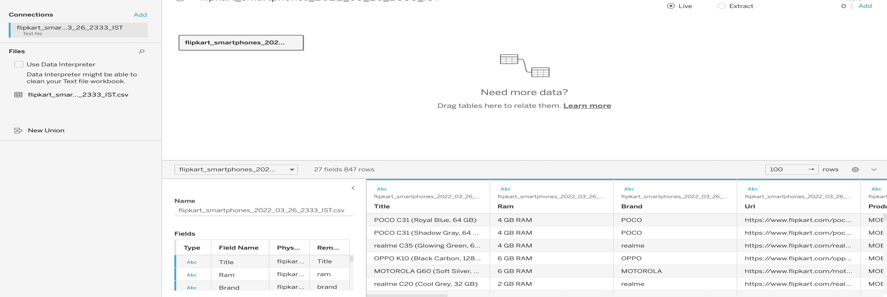

Here, In Figure 1 in the title column has multiple data including product color and internal memory

**Figure 2**

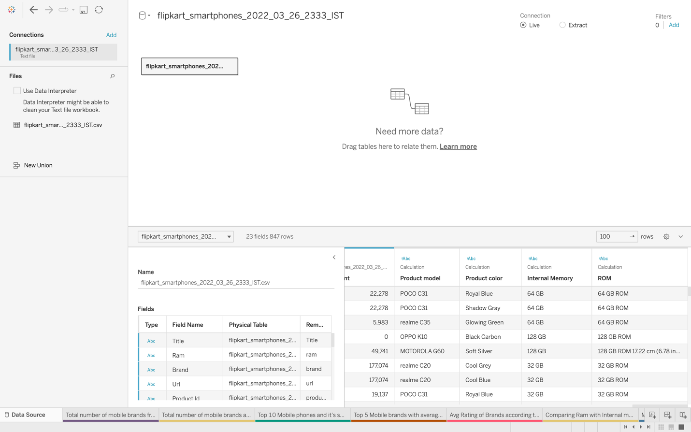

The dataset from figure 2 can be seen the data is divided into two columns as product color and Internal memory.

# **Charts**

**Figure 3**

1. **Data source project details**

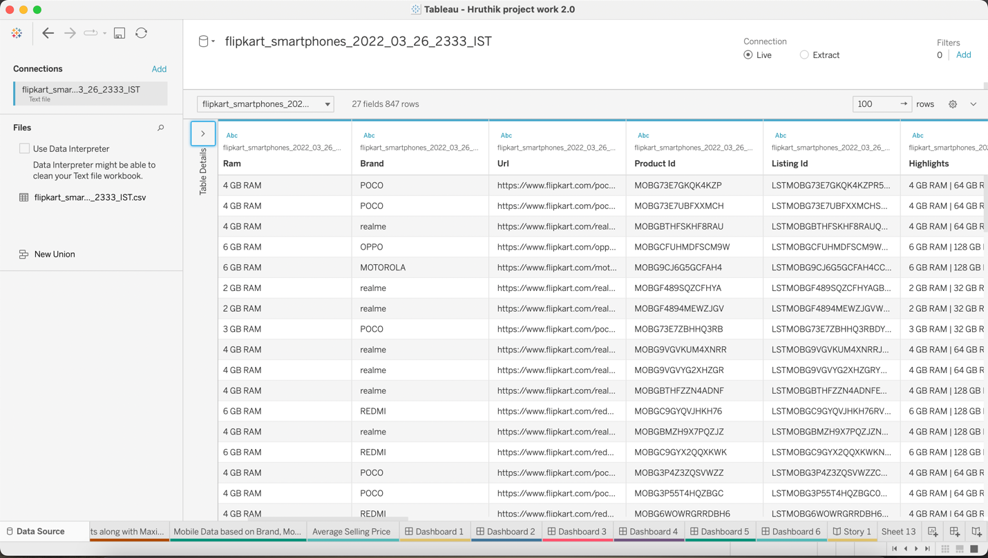

Figure 3 gives information regarding the details of the project along with the title of the mobile brand along with product names and internal memory accordingly to ram, brand, URL, product id, and list of highlights. The title column has been split into product model, product color, and internal memory. For this, I have used a split option to display the other columns. Moreover, additional spaces have been removed for a new column.

**Figure 4**

1. **Number of mobile brands using a Packed bubble chart**

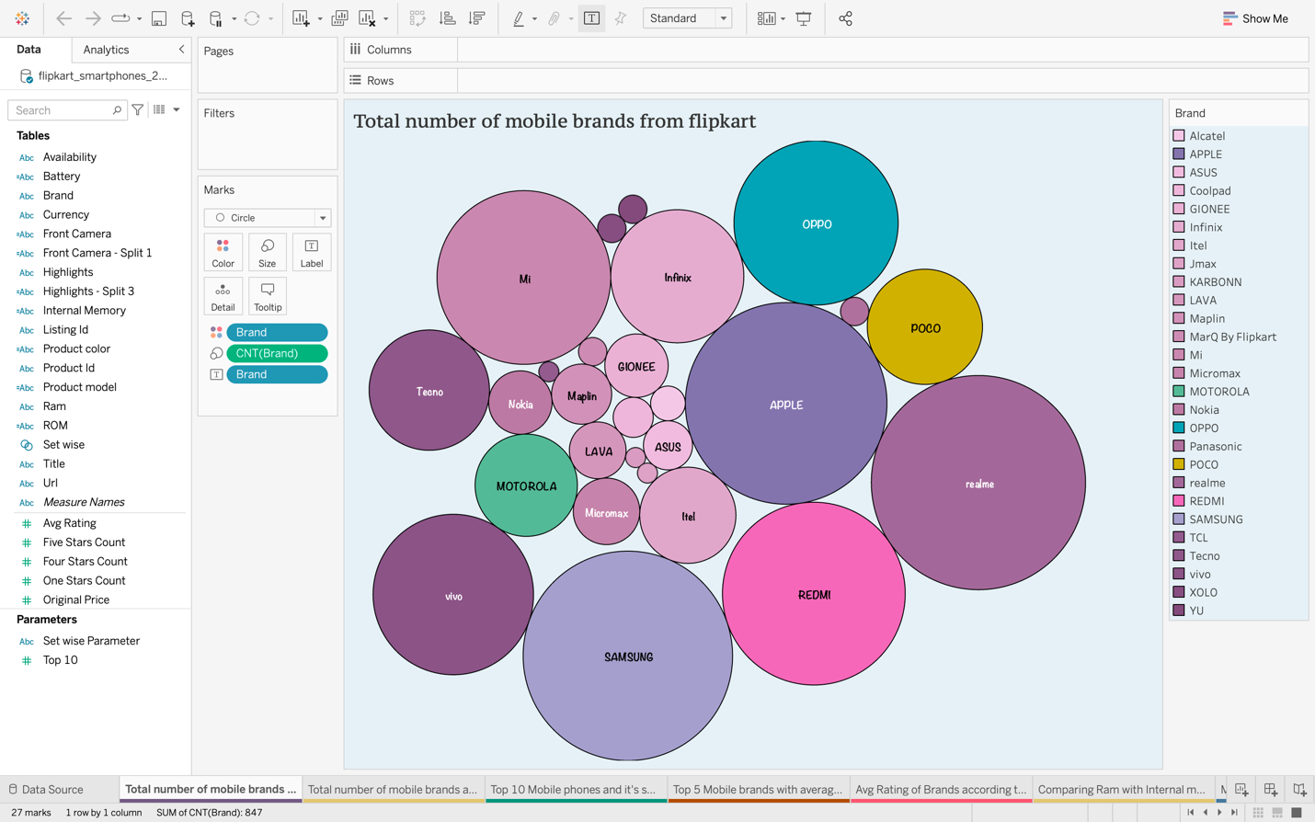

Here, In Figure 4 various brands have been displayed using a packed bubble chart which is very useful in identifying which mobile brand to choose. Represents different mobile brands with different colors in the dataset. The information provided by this chart of each brand is displayed by size. large size has a huge amount of product models whereas small size describes less amount of product models.

**Figure 5**

1. **Comparison between Avg original price and Avg selling price using scatter plot graph**

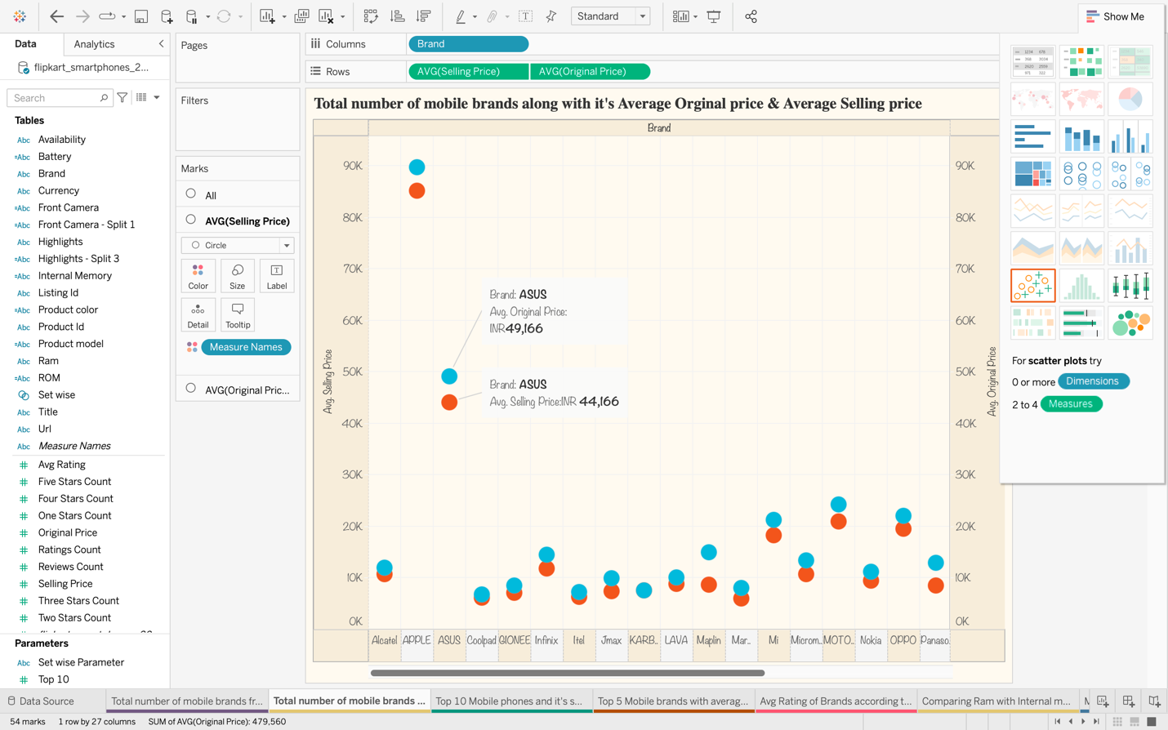

Color Legend

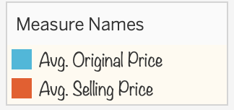

The total number of mobile brands along with their average original price and average selling price. Each brand has its price in Indian currency. For instance, the Asus mobile’s original price is 49,166 rupees represents in blue color whereas the selling price is 44,166 rupees represents in red color.

**Figure 6**

1. **Top 10 mobile phones using lollypop graph including circle & bar charts**

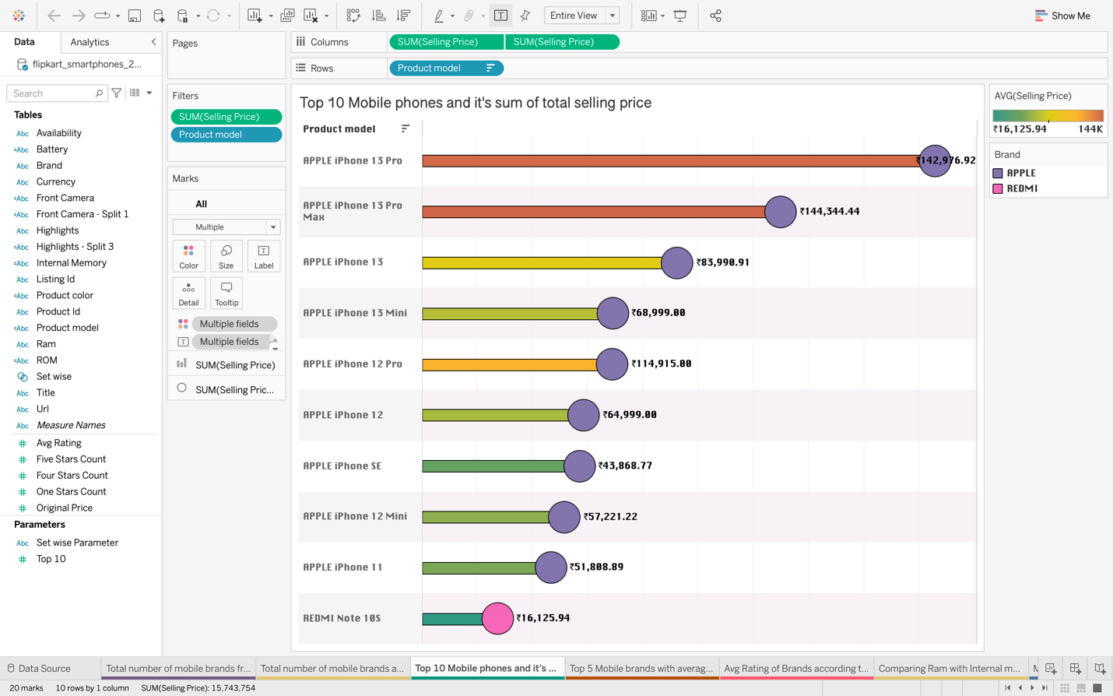

Color Legend

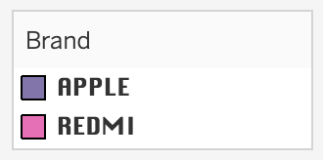

The lollypop chart in figure 6 illustrates the top 10 mobile phones and their average total selling price. According to two different brands Apple & Redmi the average selling price of each product model is displayed with the price tag. Apple iPhone 13 pro represents with the highest price of rupees 142,976 in India whereas the Redmi note 10s represents with least price of rupees 16,125. Using the lollypop graph we can display the status of the selling price in India.

**Figure 7**

1. **Bar chart of top 5 mobile brand’s rating status**

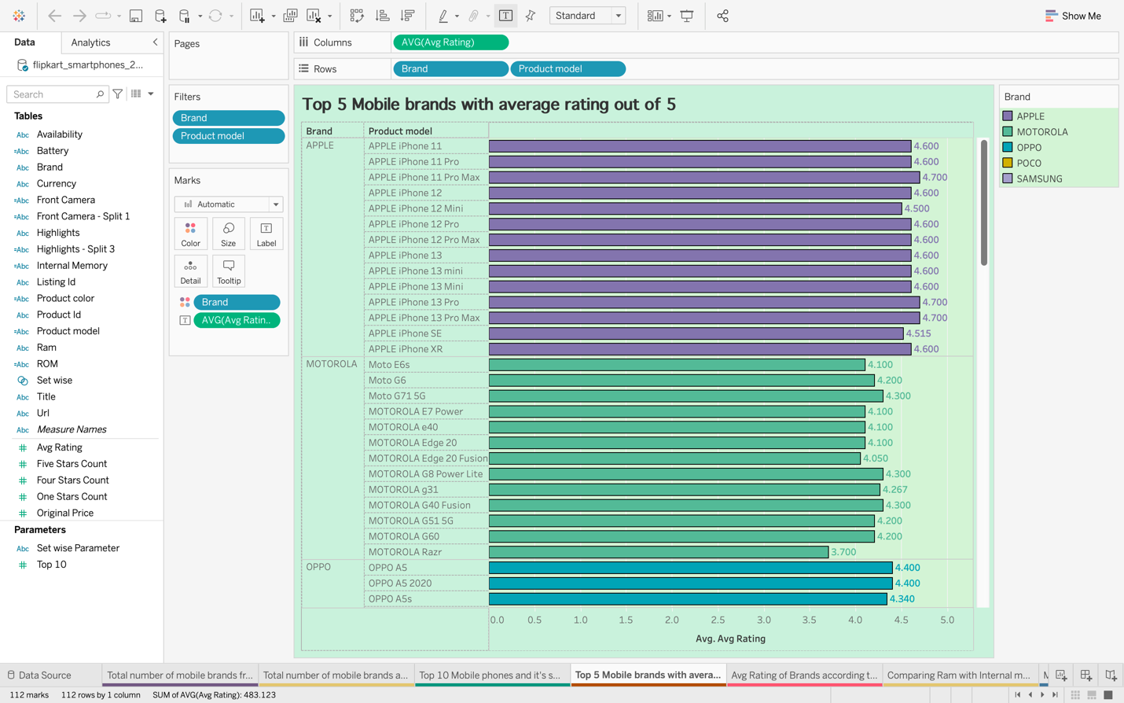

Color Legend

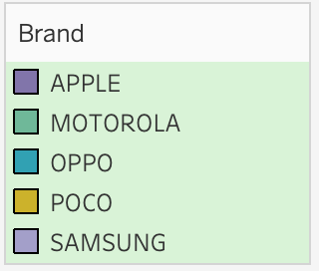

The bar chart shown in figure 7 represents the average rating status of the top 5 mobile products with their respective brand. Each mobile has its own rating out of 5.

**Figure 8**

1. **Bar chart for mobile brand’s color rating**

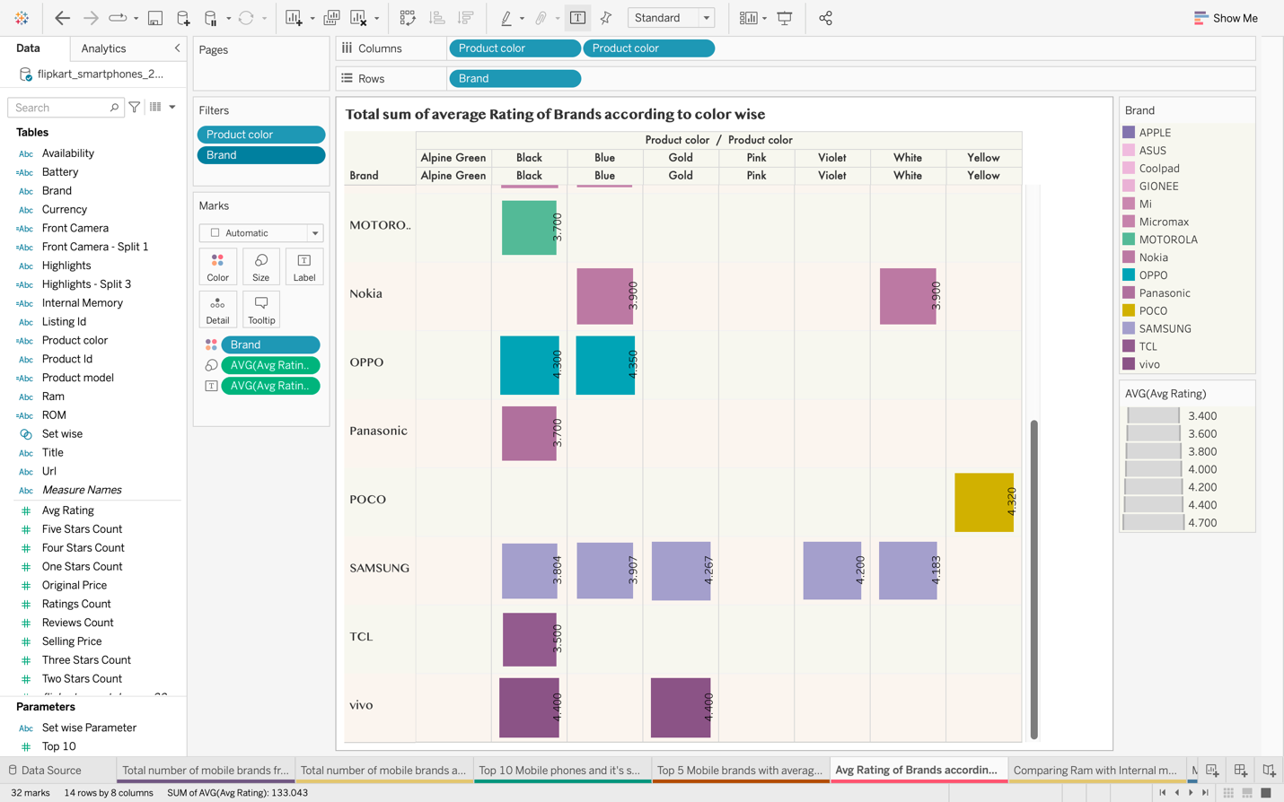

The bar chart shown in figure 8 represents the total average rating of brands according to color-wise. Out of 5 ratings each mobile brand has its own rating for different colors. For Instance, the Motorola brand has a 3.7 rating out of 5 for black color. Each mobile brand has a rating out of 5 for different colors.

**Figure 9**

1. **Comparison between internal memory with ram using scatter plot chart**

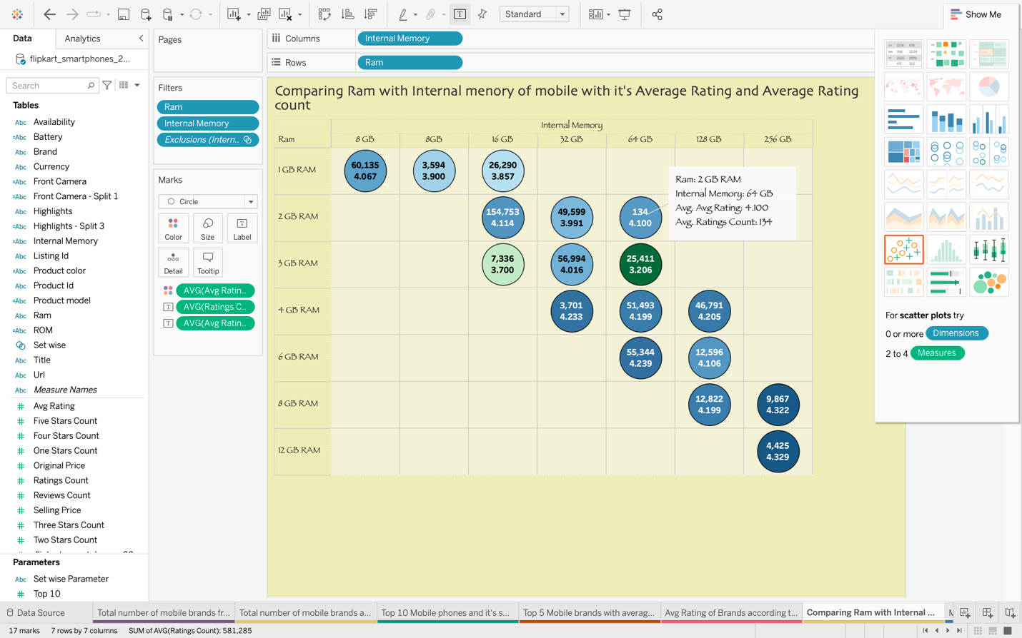

The circle chart in figure 9 illustrates the mobile brand’s average rating and average rating count compared with internal memory and ram size. For example, here circle graph gives information for 64 GB internal memory and 2 GB Ram size the average rating is 4.1 out of 5 ratings and the total average rating count is 134.

**Figure 10**

1. **Circle chart of a particular brand POCO**

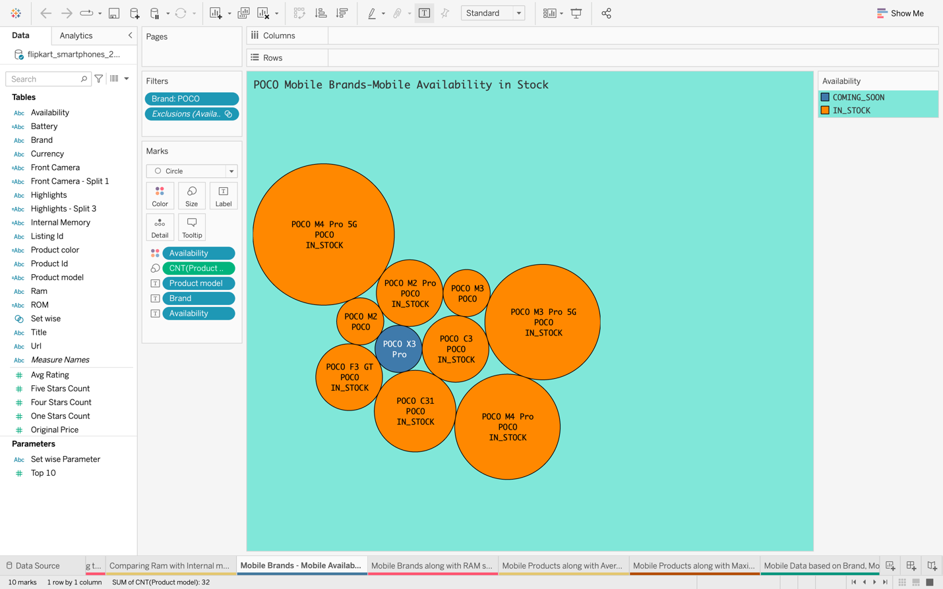

Color Legend

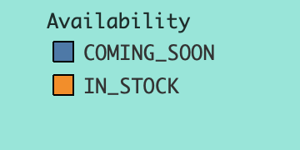

The chart shows the availability of various POCO mobile products on Flipkart. Here, POCO X3 Pro displays as coming soon in blue color and the remaining models portray as available in stock in orange color.

**Figure 11**

1. **Bar chart of ram size and mobile count**

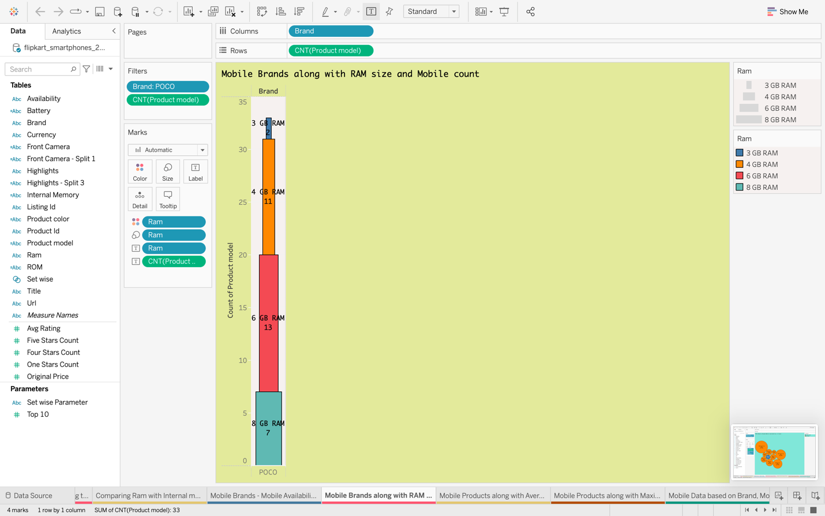

Color Legends

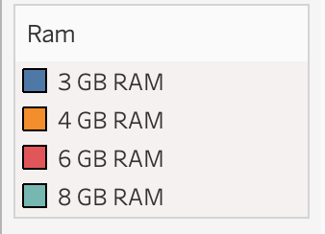

The bar graph in figure 11 illustrates the count of mobiles based on brands and their ram size and total count. POCO has 8GGB ram with 3 products and 3GB ram with 2 products.

**Figure 12**

1. **Bar chart & circle chart of average rating count and average reviews count**

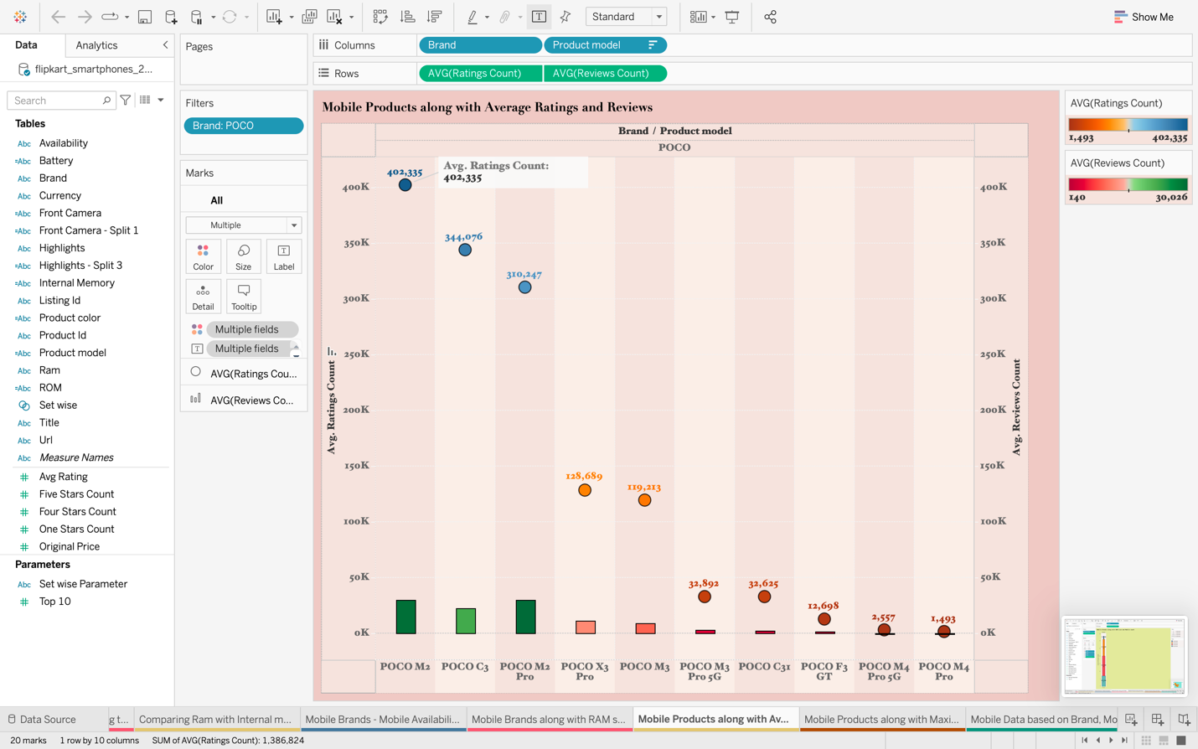

The bar chart shown in figure 12 represents checking the mobile products along with the average rating count and average reviews count. Here POCO M2 has a 402,335 average rating count. Where the highest number of ratings and reviews is POCO M2 and POCO M4 pro has the lowest.

**Figure 13**

1. **Circle chat compares both the average rating count and maximum rating count**

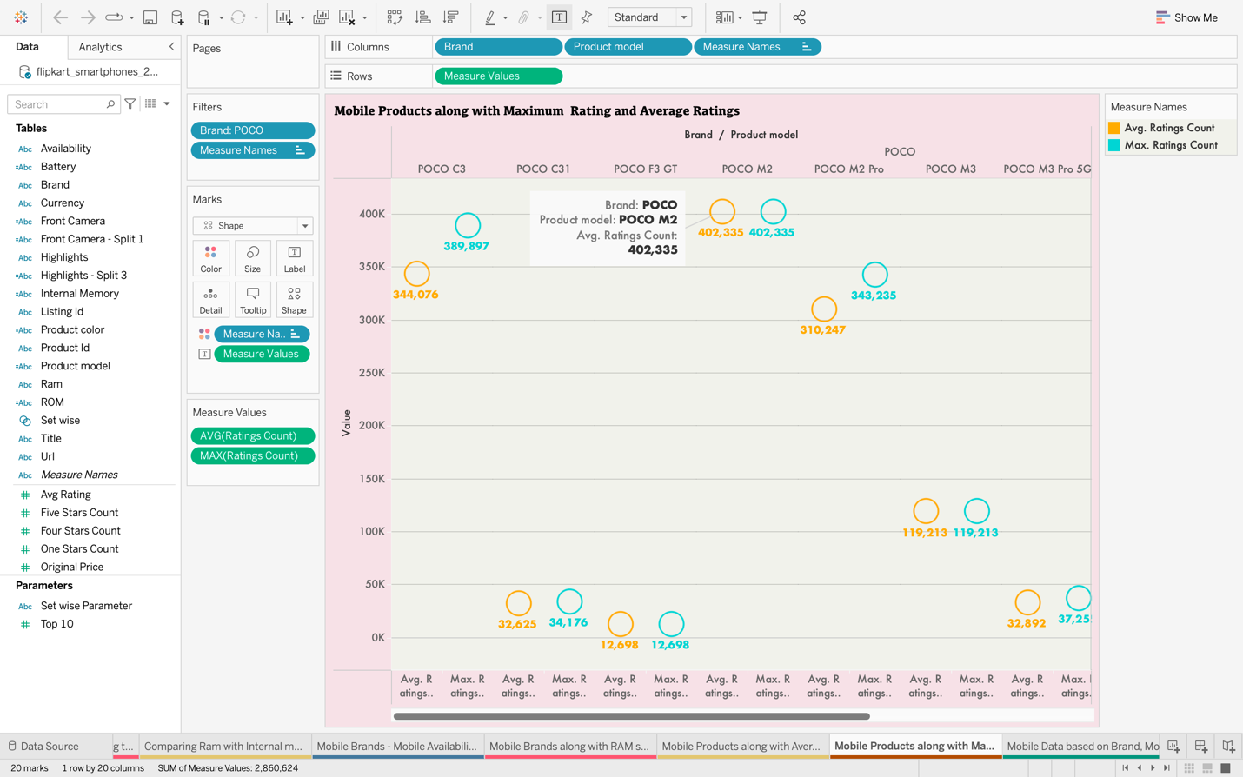

Color Legend

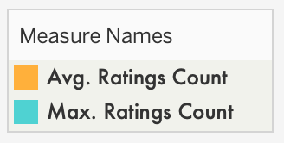

The circle chat in figure 13 compares POCO mobile products along with the average rating and maximum rating. Here POCO mobile and its models with average ratings and maximum ratings whereas POCO M2 has both maximum ratings and average ratings of 402,335.

**Figure 14**

1. **Bar chart and grant chart compares the average original price and average selling price of a particular brand POCO**

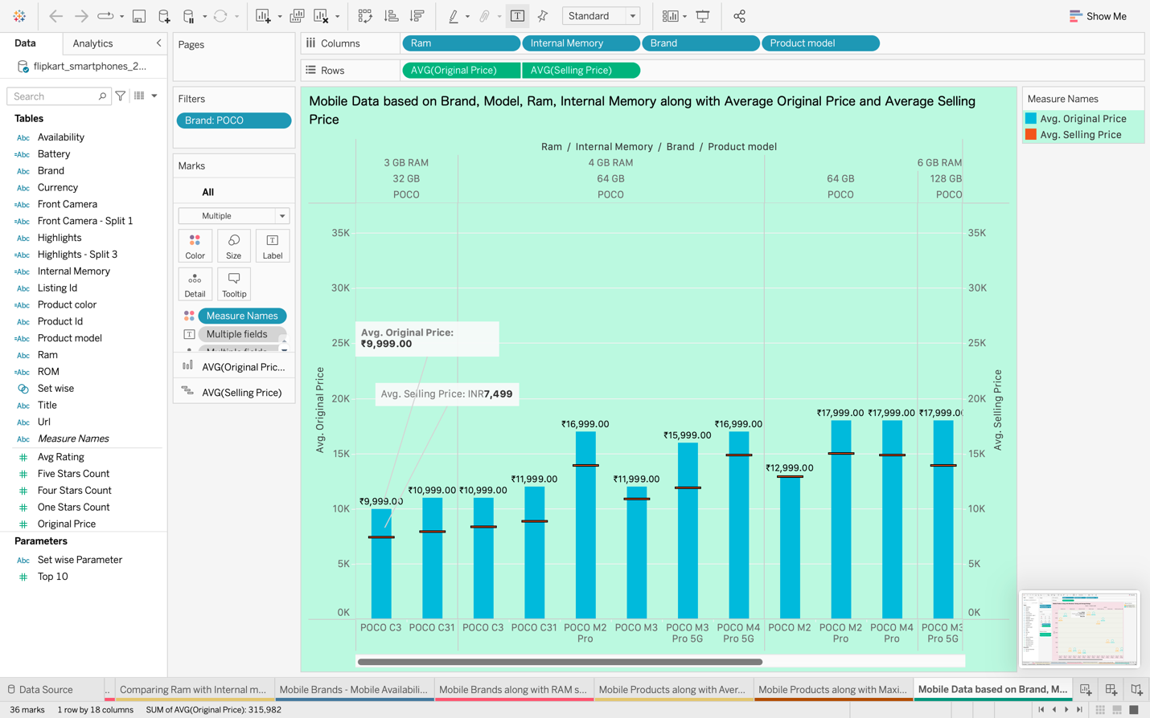

Color Legend

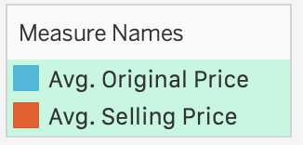

The bar chart and grant chart in figure 14 illustrates the average original price and average selling price of POCO mobile brand data based on a model, brand, ram, and internal memory. The average original and selling price of POCO mobile brand where POCO C3 model with 3 GB RAM and 32 GB internal memory the average original price is 9,999 rupees and 7,499 rupees of the average selling price.

**Figure 15**

1. **The Bar chart represents each star rating count of POCO product models**

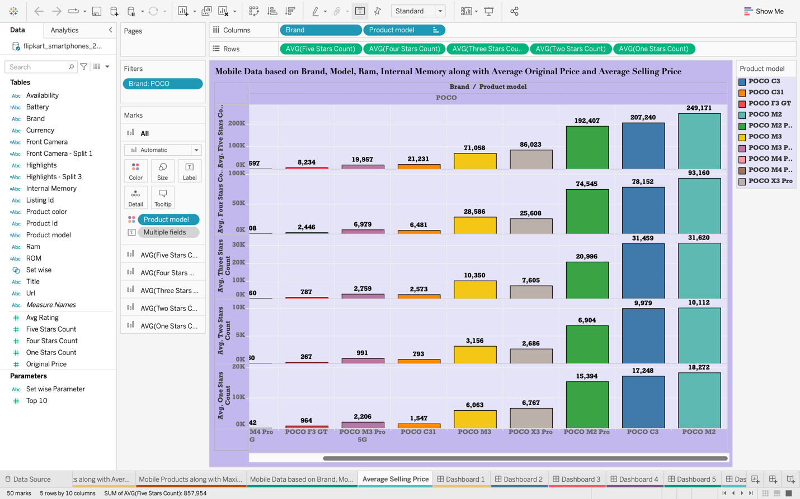

The bar chart illustrates the average ratings of various models of POCO mobiles with ratings 1 to 5. The various models of POCO mobile’s average ratings individually with ratings from 1 to 5-star ratings. The POCO M2 model has an average five-star rating of 249171, a four-star rating of 93160, a three-star rating of 31620, a two-star rating of 10112, and a one-star rating of 18272.

# **Dashboards**

## **First Dashboard – The original price vs the selling price of each mobile brand**

**Figure 16**

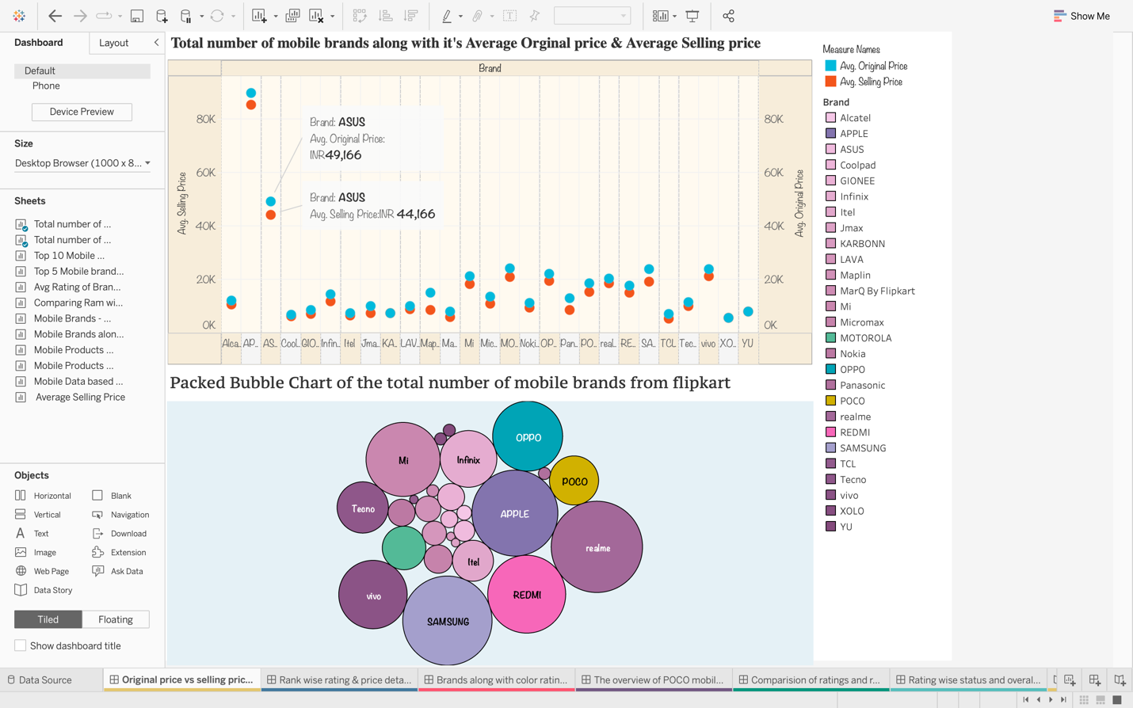

The first dashboard shown in figure 16, is about the total number of mobile brands from Flipkart and the average original price Vs the average selling price of each mobile brand, it consists of charts for:

* Total number of mobile brands from Flipkart
* Total number of mobile brands along with their Average Original price & Average Selling price

It is an interactive dashboard; All the mobile brands are applied as a filter for the above chart in the dashboard where you can select any brand, and we can see its original price and selling price.

**Second Dashboard – The overview of POCO mobile brand**

**Figure 17**

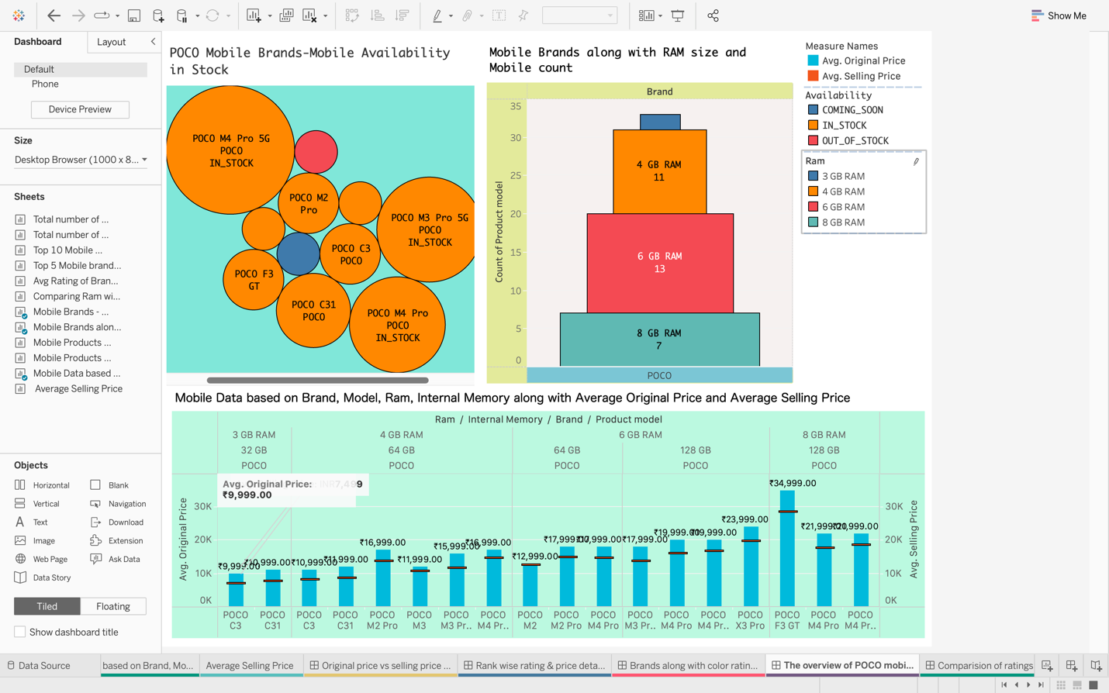

The second dashboard shown in figure 17, is about POCO mobile analysis. It provides details about the stock availability along with ram size & mobile count and compares the original price with Flipkart’s selling price.

It’s an interactive dashboard, where ram size and the mobile count are applied as a filter across the dashboard. By selecting each ram size, we can see its product availability with both original and selling prices as well.

# Overall Conclusion

I can conclude that in this project I have created several dashboards, stories, and visualization. On the Flipkart e-commerce platform, customers can scrutinize various mobile stock availability, selling prices, original prices, ratings, and specifications. Reviews count and average ratings are compared and proclaimed the original price and Flipkart’s selling price, and the user average rating from one to five stars are stated for various mobile brands. Eventually, by viewing these charts it is accessible to end users to opt for the mobile of their choice.

# **References**

The Flipkart smartphones dataset has been downloaded from Kaggle.

The dataset contains various product models, highlights, price details, review details, and rating details of various smartphone brands in India from an e-commerce website known as ‘Flipkart’ for the search URL.

* <https://www.kaggle.com/datasets/jithinanievarghese/flipkart-smartphones-dataset>